**Name: Shashwat Tripathi**

**D10A 58**

**Batch C**

**Computer Network Lab**

**Code:**

#Create a simulator object

set ns [new Simulator]

#Open the nam trace file

set nf [open out.nam w]

$ns namtrace-all $nf

#Define a 'finish' procedure

proc finish {} {

global ns nf

$ns flush-trace

#Close the trace file

close $nf

#Executenam on the trace file

exec nam out.nam &

exit0

}

#Create four nodes

set n0 [$ns node]

set n1 [$ns node]

set n2 [$ns node]

set n3 [$ns node]

set n4 [$ns node]

set n5 [$ns node]

#Change the shape of center node in a star topology

$n0 shape square

#Create links between the nodes

$ns duplex-link $n0 $n1 1Mb 10ms DropTail

$ns duplex-link $n0 $n2 1Mb 10ms DropTail

$ns duplex-link $n0 $n3 1Mb 10ms DropTail

$ns duplex-link $n0 $n4 1Mb 10ms DropTail

$ns duplex-link $n0 $n5 1Mb 10ms DropTail

#Create a TCP agent and attach it to node n0

set tcp0 [new Agent/TCP]

$tcp0 set class_ 1

$ns attach-agent $n1 $tcp0

#Create a TCP Sink agent (a traffic sink) for TCP and attach it to node n3

set sink0 [new Agent/TCPSink]

$ns attach-agent $n3 $sink0

#Connect the traffic sources with the traffic sink

$ns connect $tcp0 $sink0

# Create a CBR traffic source and attach it to tcp0

set cbr0 [new Application/Traffic/CBR]

$cbr0 set packetSize_ 500

$cbr0 set interval_ 0.01

$cbr0 attach-agent $tcp0

#Schedule events for the CBR agents

$ns at 0.5 "$cbr0 start"

$ns at 4.5 "$cbr0 stop"

#Call the finish procedure after 5 seconds of simulation time

$ns at 5.0 "finish"

#Run the simulation

$ns run

**Output:**

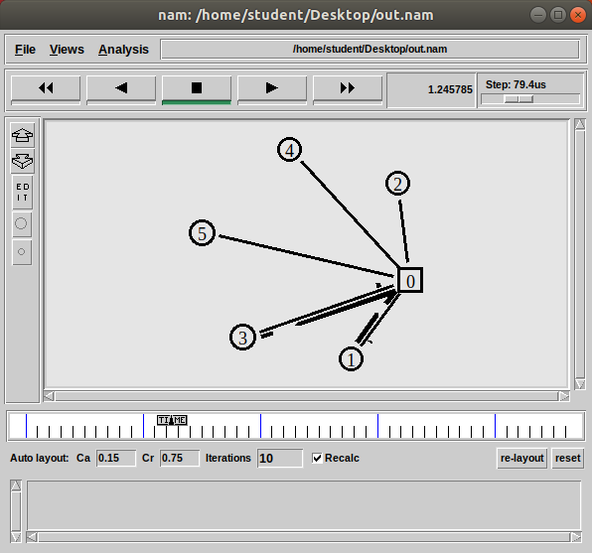

**Ring Topology**

**Code:**

#Create a simulator object

set ns [new Simulator]

#Open the nam trace file

set nf [open out.nam w]

$ns namtrace-all $nf

#Define a 'finish' procedure

proc finish {} {

global ns nf

$ns flush-trace

#Close the trace file

close $nf

#Executenam on the trace file

exec nam out.nam &

exit0

}

#Create four nodes

set n0 [$ns node]

set n1 [$ns node]

set n2 [$ns node]

set n3 [$ns node]

set n4 [$ns node]

set n5 [$ns node]

#Change the shape of center node in a star topology

$n0 shape square

#Create links between the nodes

$ns duplex-link $n0 $n1 1Mb 10ms DropTail

$ns duplex-link $n1 $n2 1Mb 10ms DropTail

$ns duplex-link $n2 $n3 1Mb 10ms DropTail

$ns duplex-link $n3 $n4 1Mb 10ms DropTail

$ns duplex-link $n4 $n5 1Mb 10ms DropTail

$ns duplex-link $n5 $n0 1Mb 10ms DropTail

#Create a TCP agent and attach it to node n0

set tcp0 [new Agent/TCP]

$tcp0 set class_ 1

$ns attach-agent $n1 $tcp0

#Create a TCP Sink agent (a traffic sink) for TCP and attach it to node n3

set sink0 [new Agent/TCPSink]

$ns attach-agent $n4 $sink0

#Connect the traffic sources with the traffic sink

$ns connect $tcp0 $sink0

# Create a CBR traffic source and attach it to tcp0

set cbr0 [new Application/Traffic/CBR]

$cbr0 set packetSize_ 500

$cbr0 set interval_ 0.01

$cbr0 attach-agent $tcp0

#Schedule events for the CBR agents

$ns at 0.5 "$cbr0 start"

$ns at 4.5 "$cbr0 stop"

#Call the finish procedure after 5 seconds of simulation time

$ns at 5.0 "finish"

#Run the simulation

$ns run

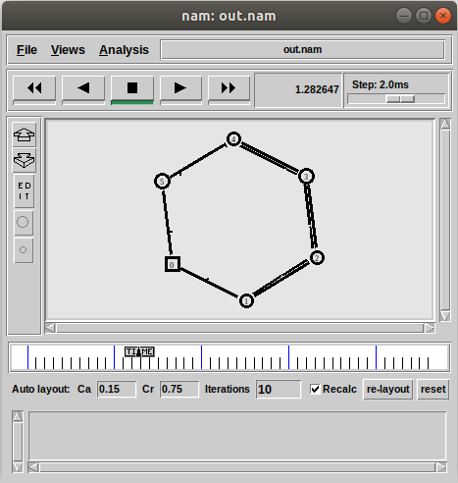

**Bus/ Hub Topology**

**Code:**

#Create a simulator object

set ns [new Simulator]

#Open the nam trace file

set nf [open out.nam w]

$ns namtrace-all $nf

#Define a 'finish' procedure

proc finish {} {

global ns nf

$ns flush-trace

#Close the trace file

close $nf

#Executenam on the trace file

exec nam out.nam &

exit0

}

#Create four nodes

set n0 [$ns node]

set n1 [$ns node]

set n2 [$ns node]

set n3 [$ns node]

set n4 [$ns node]

set n5 [$ns node]

set n6 [$ns node]

set n7 [$ns node]

#Change the shape of center node in a star topology

$n0 shape square

#Create links between the nodes

$ns duplex-link $n0 $n1 1Mb 10ms DropTail

$ns duplex-link $n1 $n2 1Mb 10ms DropTail

$ns duplex-link $n2 $n3 1Mb 10ms DropTail

$ns duplex-link $n3 $n4 1Mb 10ms DropTail

$ns duplex-link $n1 $n5 1Mb 10ms DropTail

$ns duplex-link $n2 $n6 1Mb 10ms DropTail

$ns duplex-link $n3 $n7 1Mb 10ms DropTail

#Create a TCP agent and attach it to node n0

set tcp0 [new Agent/TCP]

$tcp0 set class_ 1

$ns attach-agent $n0 $tcp0

#Create a TCP Sink agent (a traffic sink) for TCP and attach it to node n3

set sink0 [new Agent/TCPSink]

$ns attach-agent $n4 $sink0

#Connect the traffic sources with the traffic sink

$ns connect $tcp0 $sink0

# Create a CBR traffic source and attach it to tcp0

set cbr0 [new Application/Traffic/CBR]

$cbr0 set packetSize_ 500

$cbr0 set interval_ 0.01

$cbr0 attach-agent $tcp0

#Schedule events for the CBR agents

$ns at 0.5 "$cbr0 start"

$ns at 4.5 "$cbr0 stop"

#Call the finish procedure after 5 seconds of simulation time

$ns at 5.0 "finish"

#Run the simulation

$ns run

